Canadians and the Weather
Investigating the Effect of Weather on House Building Materials
Teacher’s Guide and Answer Key

Task
Investigate the effect of rain, and heat or cold on building materials used by Aboriginal Peoples and early settlers in Canada. Select different building materials and design an experiment to test the effectiveness of the materials against rain. Using the same materials, design a second experiment to test the effectiveness of the materials against heat or cold.

Materials for a class of 32 students
You may not be able to supply all building materials. Tell the students which materials are not available or delete them from the student list of materials. Have half the students start their rain experiment and have the other half start with the heat experiment to reduce the need for specific equipment. Building material samples should be at least 20 cm square for the experiments.

1 roll sod (garden centre)
animal hides (4 suede and 4 fur cut into 15 cm squares)
4 15cm square pieces of birch bark (do not remove from live trees – contact tree removal company for bark from various trees. Do not use pine or spruce because the sap is messy)
4 15cm square pieces of elm bark (see birch bark)
4 15cm square pieces of cedar bark (see birch bark)
1 bucket soil (from your garden or a garden centre)
spruce boughs (from your garden or tree removal company)
4 15 cm square pieces of cedar plank (grocery store or building store)
4 15 cm square pieces of other wood planks (building store)
4 15 cm diameter stones (building store)
4 bricks (building store)
8 wood shingles (building store)
8 slate shingles (building store)
4 pieces of 15 cm sheet metal (or cookie sheets or baking pans)
6 ice blocks (make ahead in plastic containers or baking pans)
6 desk lamps with incandescent bulb, or spot light, retort stand and clamp
15 thermometers
6 spray bottles
water
paper towels
rags for clean up

Prediction
Select at least two of the available materials to test. Choose at least one Aboriginal house material. Decide whether you are going to test for effectiveness against heat or cold.

The materials that I am going to investigate are list at least two materials.

I think various answers will be most effective against rain.

I think various answers will be most effective against heat/cold (circle one).

Teacher Preparation
- Prepare for this activity ahead of time by freezing blocks of ice in plastic containers or cake pans.
- Sod and soil can be purchased from a garden centre.
- Bark and spruce boughs can be obtained from tree removal companies.
- Cedar planks can be purchased from grocery stores (expensive).
- Cedar planks, other wood planks, stone, brick, wood shingles, slate shingles can be purchased from building stores.

Safety
- The lamps will get hot. Instruct students not to touch the lamps.
- If water is sprayed on hot lamps they could implode. Instruct students to make sure there are no hot lamps nearby when they spray water.
- Be sure to position tables beside electrical outlets so that power cords are not a trip hazard.
- You may need to use power bars so that there are enough electrical outlets.
- Leave clean up until after students write their conclusions so that the lamps have a chance to cool.

Action
Students need to show the teacher their two sketches of their experimental designs and their two results tables to get permission to begin the experiment. Following are samples of sketches and results tables. Note that the students get to select how many materials they will test.

Effect of rain (2I, 2C)
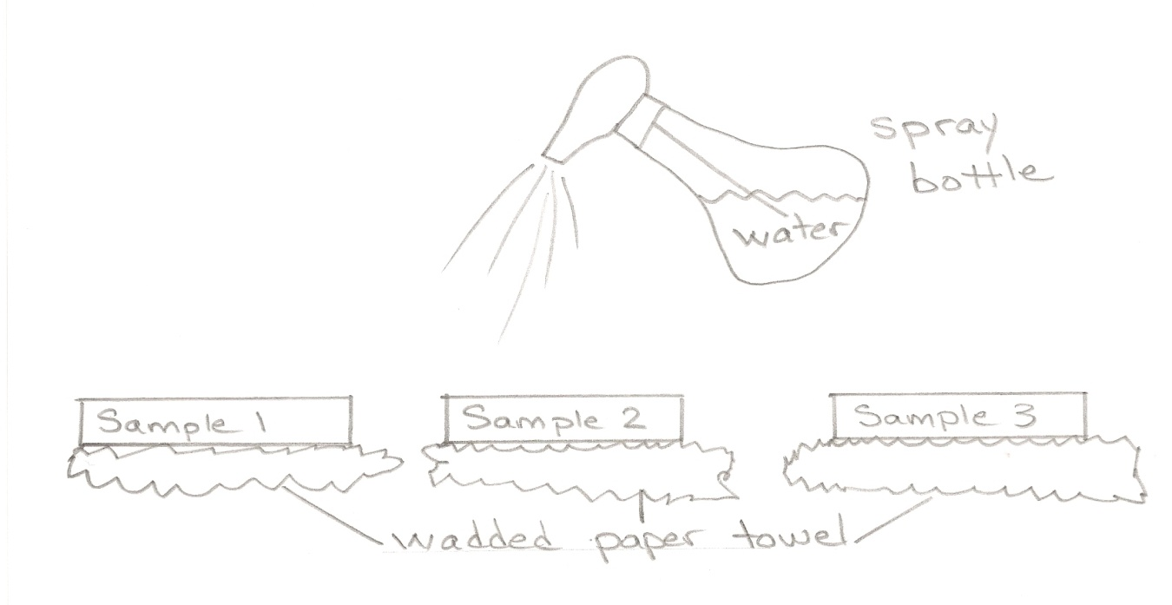
Effect of heat (2I, 2C)
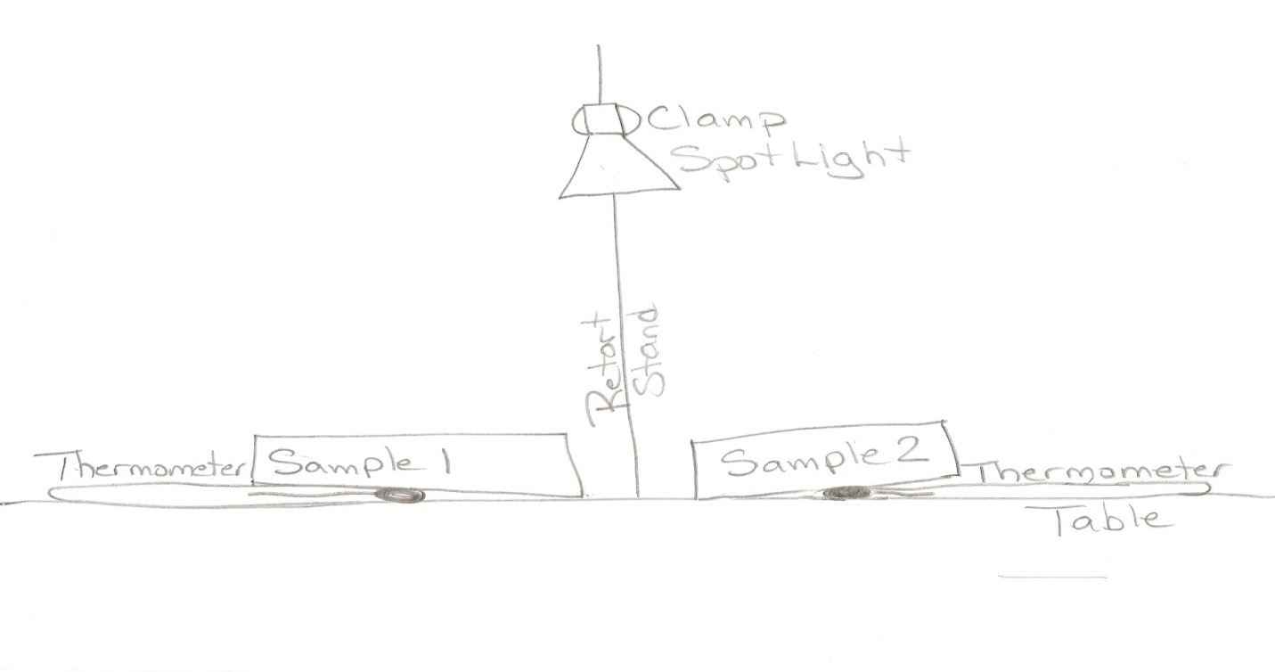
Effect of cold (2I, 2C)
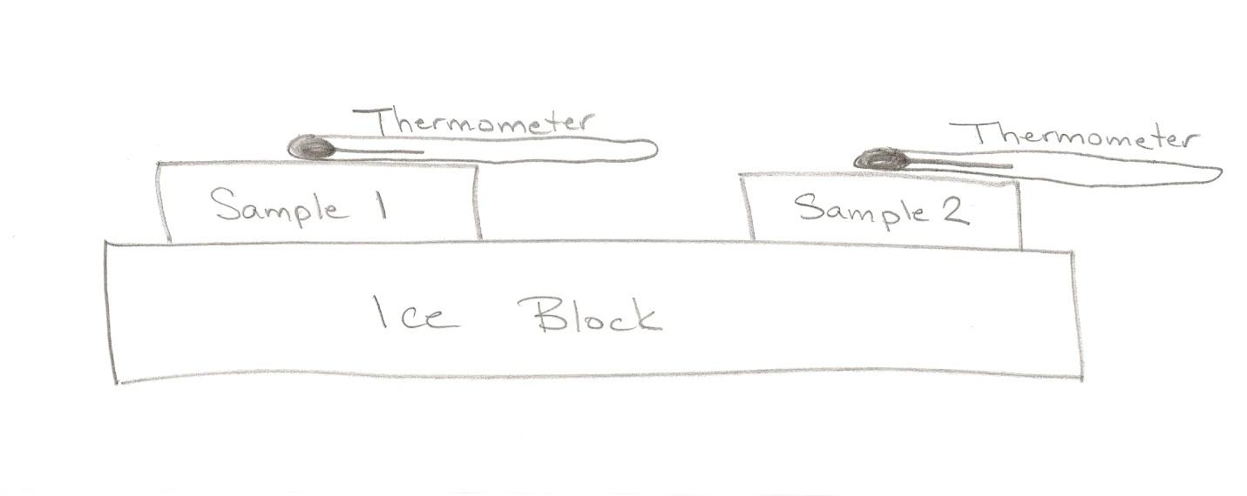

Effect of rain (qualitative results) (3I, 1C)
 | Sample 1 | Sample 2 | Sample 3
0 sprays from bottle
5 sprays from bottle
10 sprays from bottle
15 sprays from bottle
20 sprays from bottle
25 sprays from bottle
30 sprays from bottle

Effect of heat or cold (3I, 1C)
 | Sample 1  Temperature (C) | Sample 2  Temperature (C)
0 minutes
2 minutes
4 minutes
6 minutes
8 minutes
10 minutes
12 minutes
14 minutes

Conclusions
Answers to most of the questions will be variable depending on the materials selected and the results of the experiments.

- Rank your materials from least to most waterproof. (1K) Various answers depending on materials selected.

- Do your results support your prediction? (1I) Yes or No

- Explain why the most waterproof material was more effective. (1I) It was the least porous material. There were no spaces between the materials. Accept any reasonable answers.

- What challenges would Aboriginal Peoples or early European settlers face with your least waterproof material? (1A) Rain could leak in or the walls would be wet causing it to be damp inside the home. Accept any reasonable answers.

- Rank your materials from greatest heat transfer to least heat transfer. (1K) Various answers depending on materials selected.

- Do your results support your prediction? (1I) Yes or No

- Explain why the material that allowed the least heat transfer was the best insulator. (1I)Electrons are not as free to move and transfer heat.

- Do you think the outcome would be different if you had tested for heat instead of cold, or cold instead of heat? Why / why not? (1A) I would expect to have the same results if I tested for heat or cold. Any material that has greater resistance to heat transfer will insulate against heat or cold.

- What challenges would Aboriginal Peoples or early European settlers face with your least insulating material? (1A) They would be hot in summer and cold in winter. They could accommodate to this by spending more time outside to keep cool in summer, and having a fire inside and wearing warm clothes during the winter.

- Which of the materials that you tested do you think is the best building material for building a house? Why? (1A) Various answers depending on materials selected. Accept any reasonable answers.

- What could you do to improve your experiment(s)? (2I) Put roofing material on an angle to replicate the slope of a roof and allow water to run off. Use a frame to hold the soil because it wouldn’t compact. Create an air space between the material and the thermometer to measure air temperature instead of material temperature. Accept any reasonable answers.

Evaluation Scheme
 | Knowledge and Understanding | Thinking and Investigation | Communication | Application
Design |  | /4 | /4
Observation Tables |  | /6 | /2
Conclusions | /2 | /6 |  | /4

Extensions
Modify the experiment to investigate the effect of rain, heat and cold on clothing materials. Compare First Nations, Inuit, settlers and modern materials.
Students use “First Nations and Inuit – Clothing” website http://www.ecokids.ca/pub/eco_info/topics/first_nations_inuit/clothing.cfm to identify historic clothing materials. Alternatively they can use the ”First Nations in Canada” webpage section on “Clothing” http://www.aadnc-aandc.gc.ca/eng/1307460755710/1307460872523.

