Protecting Our Water
Media Report – Teacher’s Guide

This is a modified RAFT assignment. RAFT stands for Role, Audience, Format and Topic. More information can be found in the article by Groenke, Susan L. and Randall Puckett. “Becoming Environmentally Literate Citizens” in The Science Teacher, Oct 31, 2006 by The National Science Teachers Association found at http://www.nsta.org/publications/news/story.aspx?id=52851&print=true. This assignment has all students working on the same topic but they choose a specific role, audience and format.

During the first class, read the assignment together and have a discussion about the social, economic, political and environmental considerations that municipal councillors should consider when voting. Individual students or teams can be consulted to choose their role and format on the signup sheet. Be very sure to get some students doing presentations that will clearly be in favour of the bottled water plant (Eg. Manager of the plant, unemployed workers representative) as well as against.

While in the computer lab writing the media reports, ensure that students writing the same media format work together to help each other with technical challenges (Eg. In PowerPoint) or to share poster making equipment like glue sticks and pencil crayons.

The composition of the groups for the final presentations should have as wide a variety of viewpoints as possible in a group of 4-5.

 | persuasive PowerPoint | opinion letter to paper | informative web page | educational poster
Manager of the drinking water treatment plant.
Unemployed Workers Association
Local Cottagers Association
Conservation Officer
Executive from the Water Bottling Company
Kids who want to swim in the river
Representative from the local First Nations community
Owner of a local fishing tourism company
local Taxpayers Association
Protecting Our Water
RAFT Sign Up Sheet

This is used to plan the teams for the final presentation.

3-2-1 Exit Card and Ballot
NAME: ____________________________
1. What are three interesting facts you learned during class today?

2. What two arguments influenced your opinion the most?

3. If you were a municipal councillor presented with this information, how would you vote?
€ I am in favour of approving the water bottling plant.
€ I am against approving the water bottling plant.

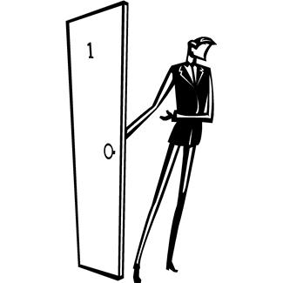

3-2-1 Exit Card
NAME: ____________________________
1. What are three interesting facts you learned during class today?

2. What two arguments influenced your opinion the most?

3. If you were a municipal councillor presented with this information, how would you vote?
€ I am in favour of approving the water bottling plant.
€ I am against approving the water bottling plant.

